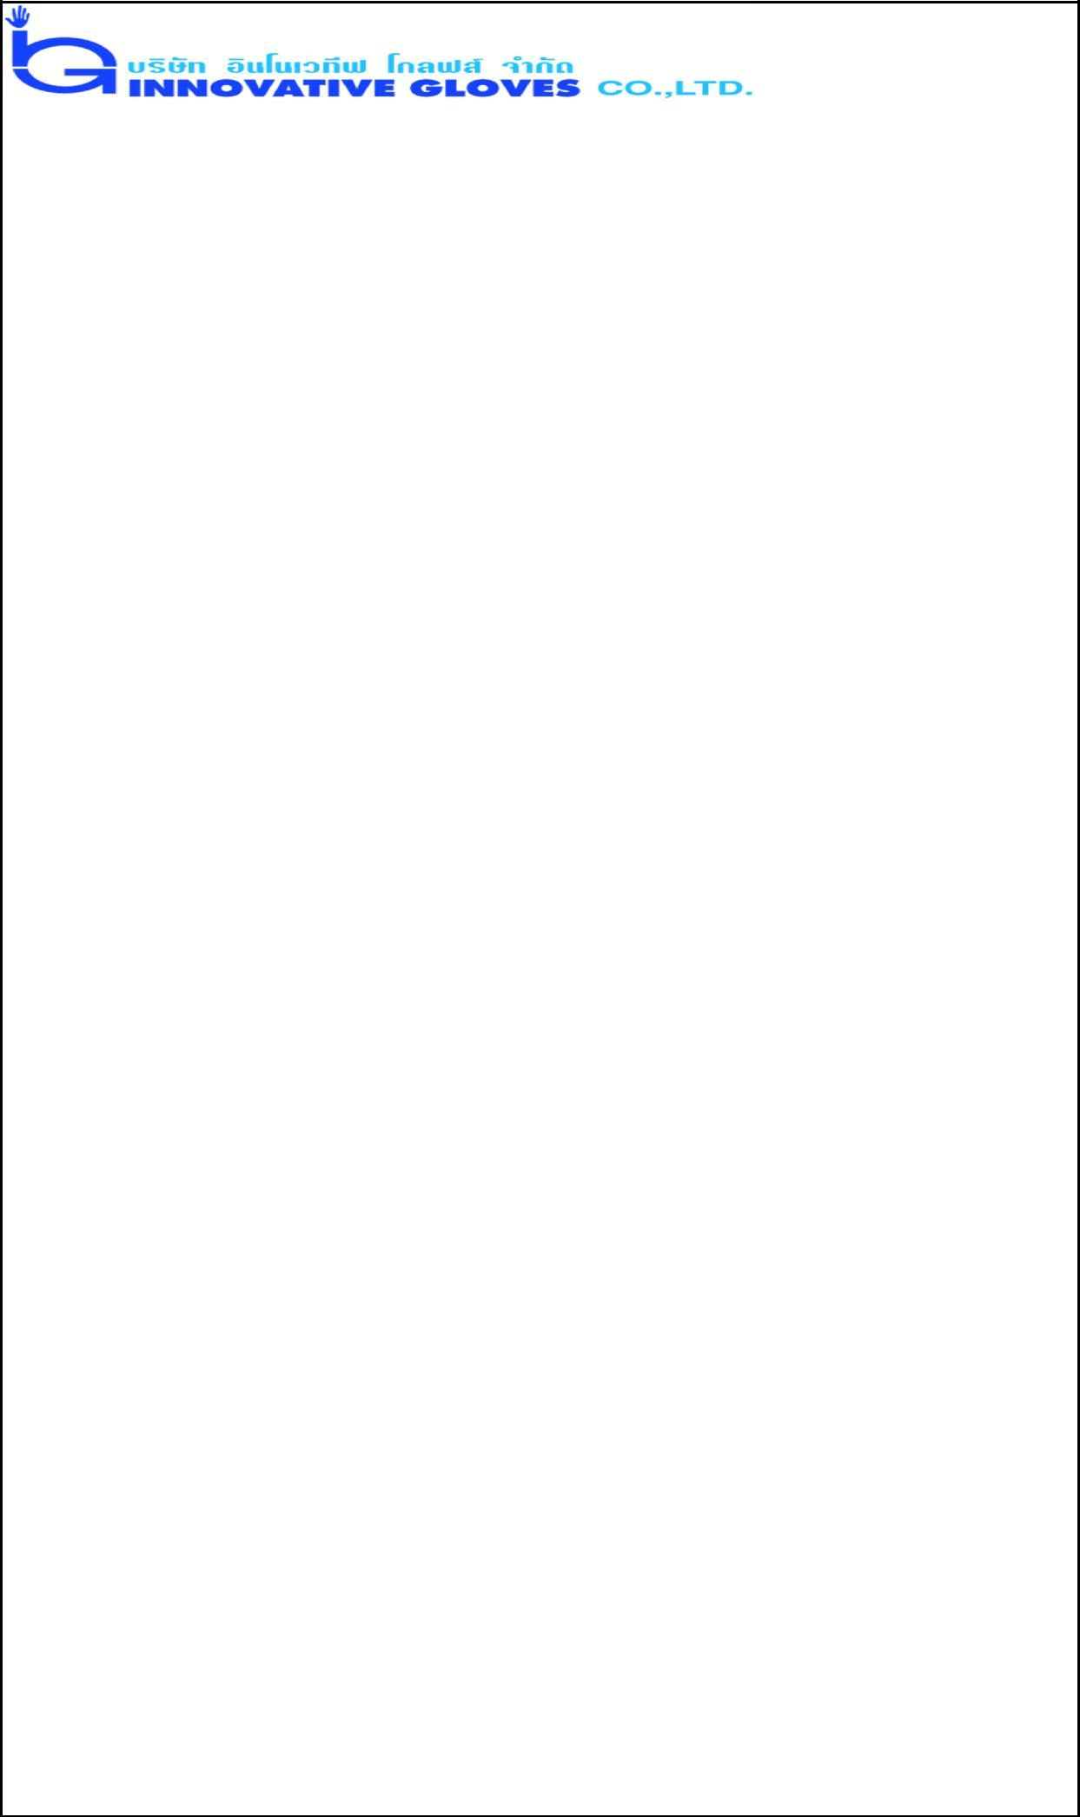

PRODUCT SPECIFICATION

Name of Product |  |  |  |  | : 9.0 Mil Powder Free Heavy Duty Nitrile Gloves.
Name of Manufacturer : Innovative Gloves Co. Ltd. Hatyai, Thailand
Base Material |  |  |  |  | : Nitriles
Characteristics |  |  |  |  | : Non Sterile, Ambidextrous Beaded Cuff
Available Sizes |  |  |  |  | : Small (7) , Medium (8), Large (9), X-Large (10) ,
Surface |  |  |  |  | XX- Large (11)
 |  |  |  |  | : Diamond Textured.
Surface Treatment |  |  |  |  | : Polymer Coating
Colour |  |  |  |  | : Dark Blue.
Physical Specifications:
 |  | Length |  |  |  |  | SINGLE WALL (mm) |  |  |  |  |  |  | Width
 | Size |  |  |  | Finger Tip |  |  |  |  | Palm |  | Cuff |  | Width
 | Size | (mm) |  |  |  |  |  |  |  | Palm |  | Cuff |  | (mm)
 |  |  |  |  | Textured |  | Smooth |  |  | Textured |  | Smooth |  | (mm)
 |  |  |  |  | Surface |  | Surface |  |  | Surface |  | Surface
 | Small | 310±15 |  |  | 0.40±0.05 |  | 0.24±0.01 |  |  | 0.45±0.05 |  | 0.12±0.01 |  | 85±5
 | -7 |  |  |  | 0.40±0.05 |  |  |  |  | 0.45±0.05 |  | 0.12±0.01 |  | 85±5
 | Mediu | 310±15 |  |  | 0.40±0.05 |  | 0.24±0.01 |  |  | 0.45±0.05 |  | 0.12±0.01 |  | 95±5
 | m - 8 |  |  |  | 0.40±0.05 |  |  |  |  | 0.45±0.05 |  | 0.12±0.01 |  | 95±5
 | Large | 310±15 |  |  | 0.40±0.05 |  | 0.24±0.01 |  |  | 0.45±0.05 |  | 0.12±0.01 |  | 105±5
 | -9 |  |  |  | 0.40±0.05 |  |  |  |  | 0.45±0.05 |  | 0.12±0.01 |  | 105±5
 | X
 | Large - | 310±15 |  |  | 0.40±0.05 |  | 0.24±0.01 |  |  | 0.45±0.05 |  | 0.12±0.01 |  | 115±5
 | 10
 | XX
 | Large - | 310±15 |  |  | 0.40±0.05 |  | 0.24±0.01 |  |  | 0.45±0.05 |  | 0.12±0.01 |  | 125±5
 | 11
 | Physical | Properties:
 |  | Before Aging |  |  |  |  |  |  |  | After Accelerated Aging
 | Tensile Strength |  | Ultimate Elongation |  |  |  |  |  | Tensile Strength |  |  | Ultimate
 |  |  |  |  |  |  |  |  |  |  |  | Elongation
 | 22 Mpa. Min. |  |  |  | 500% Min. |  |  |  | 22 Mpa. Min. |  |  | 400% Min
Total Residue Content |  |  |  |  |  |  | - < 2.0 Milligrams per glove
Packaging (Normal) |  |  |  |  |  |  | - 50 pieces in one Poly Bag or Inner Box
 |  |  |  |  |  |  | 10 Poly Bags or Inner Box in one Carton
Labeling on Polybag (Normal) |  |  |  |  |  |  | - Product Name, Size,
Labeling on Carton (Normal) |  |  |  |  |  |  | - Product Name, Size, Lot no. Quantity,
 |  |  |  |  |  |  | Country of Origin

